

University of Tabriz, Faculty of Electrical and Computer Engineering

Department of Biomedical Engineering

Title

**Digital Feedforward Compressor Design and Implementation**

**(using Matlab Audio System Toolbox)**

Supervisor

**Dr. Masoud Geravanchizadeh**

Researcher

**Samira Abedini**

Date

October 2021

# Theory

Dynamic range control is the adaptive adjustment of the dynamic range of a signal. The dynamic range of a signal is the logarithmic ratio of maximum to minimum signal amplitude specified in dB.

You can use dynamic range control to:

* Match an audio signal level to its environment
* Protect AD converters from overload
* Optimize information
* Suppress low-level noise

Types of dynamic range control include:

* Dynamic range compressor –– Attenuates the volume of loud sounds that cross a given threshold. They are often used in recording systems to protect hardware and to increase overall loudness.
* Dynamic range limiter –– A type of compressor that brickwalls sound above a given threshold.
* Dynamic range expander –– Attenuates the volume of quiet sounds below a given threshold. They are often used to make quiet sounds even quieter.
* Noise gate –– A type of expander that brickwalls sound below a given threshold.

This tutorial shows how to implement dynamic range control systems using the compressor, expander, limiter, and noiseGate System objects from Audio Toolbox™. The tutorial also provides an illustrated example of dynamic range limiting at various stages of a dynamic range limiting system.

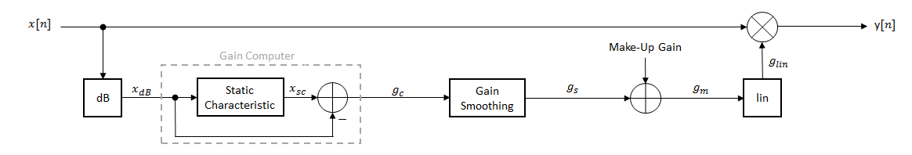

**Figure 1:** The diagram depicts a general dynamic range control system.

In a dynamic range control system, a gain signal is calculated in a sidechain and then applied to the input audio signal. The sidechain consists of:

* Linear to dB conversion:x→xdB
* Gain computation, by passing the dB signal through a static characteristic equation, and then taking the difference: gc=xsc−xdB
* Gain smoothing over time: gc→gs
* Addition of make-up gain (for compressors and limiters only): gs→gm
* dB to linear conversion: gm→glin
* Application of the calculated gain signal to the original audio signal: y=glin×x

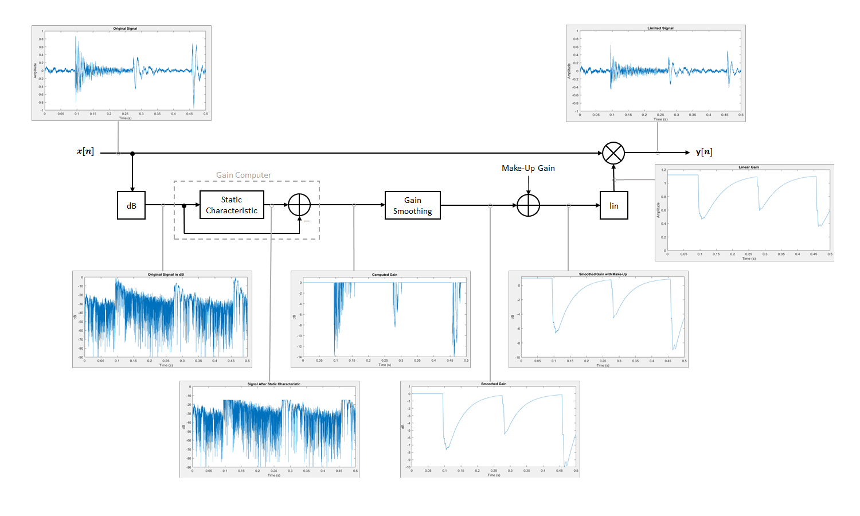

**Figure 2:** The diagram depicts a detailed block diagram of dynamic range control system.

* More detailed information can be found in:

<https://www.mathworks.com/help/audio/ug/dynamic-range-control.html>

# The Structure of Programs

In this project Matlab audio system toolbox compressor function was used.

# Main Function:

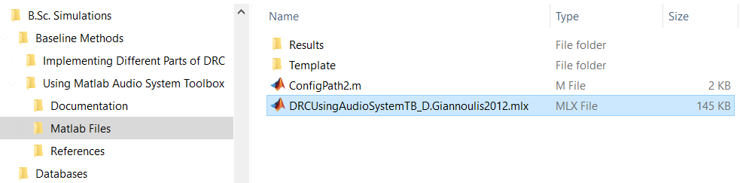

* **DRCUsingAudioSystemTB_D.Giannoulis2012.mlx**

**Description:**

In this live script Matlab file, the compressor function from audio system toolbox was used to compress the input signal. It has three stages:

* At first the dsp.AudioFileReader and audioDeviceWriter System objects™ were set up to read the information of input signal.
* Then the ‘compressor’ function (from audio system toolbox) was called and compressor parameters were set up to have a threshold of -15 dB, a ratio of 7, and a knee width of 5 dB.
* At the end the processed audio will be visualized on the scope and played.

Matlab help was used to create this live script. Stages are described as:

# 2.1 Stage 1: Search for ‘Audio System Toolbox’ in help

Search for ‘Audio System Toolbox’ in help as shown below.



# 2.2 Stage 2: Click on ‘Audio System Toolbox - Design and test audio processing systems’

From the results click on ‘Audio System Toolbox - Design and test audio processing systems’ as shown below.

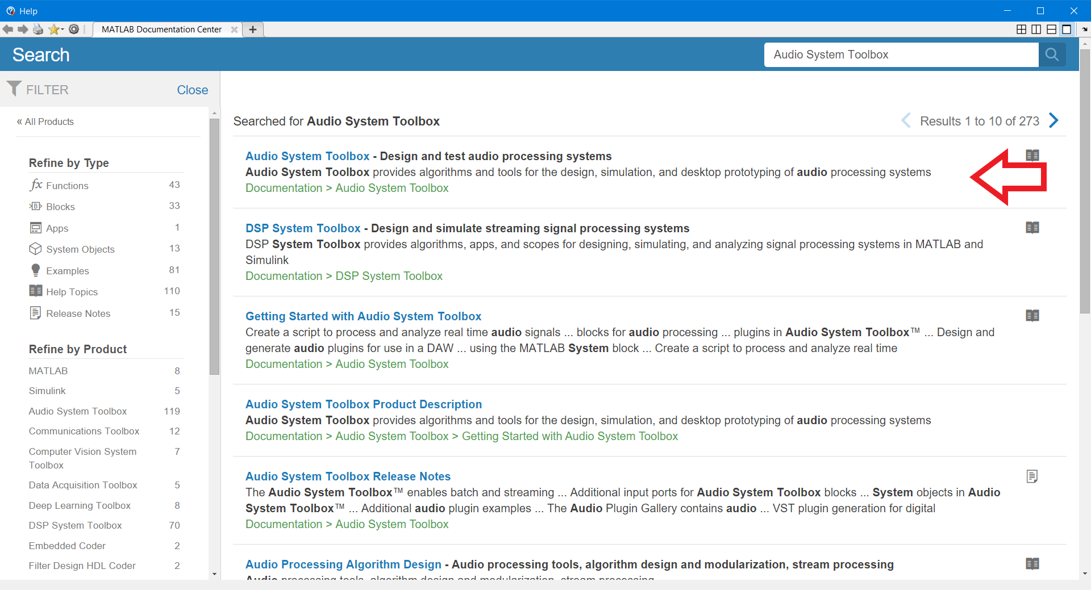

# 2.3 Stage 3: click on ‘Audio Processing Algorithm Design’

From the contents of Audio System Toolbox click on ‘Audio Processing Algorithm Design’.

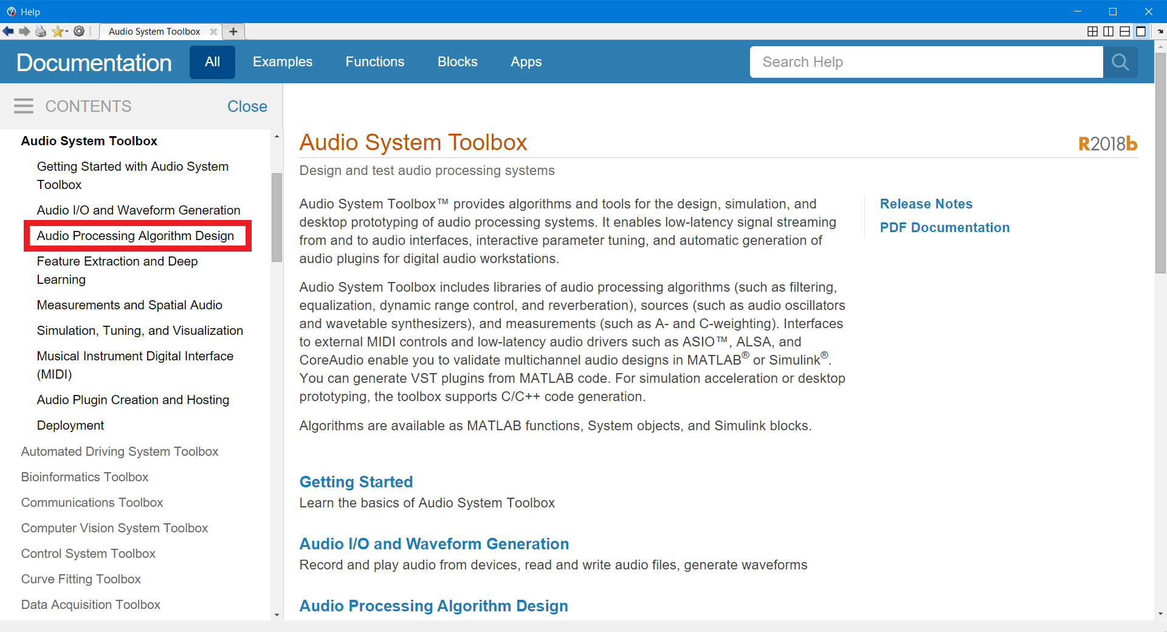

# 2.4 Stage 4: click on ‘Compressor’

From ‘System Objects/Effects and Dynamic Range Control’ click on ‘Compressor’.

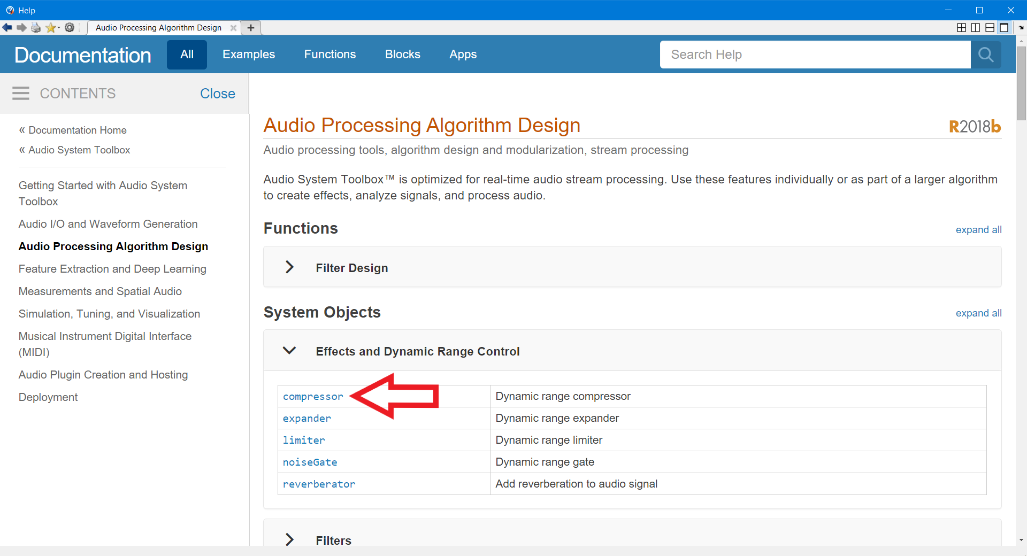

# 2.5 Stage 5: click on ‘Examples’

Click on ‘Examples’ from contents.

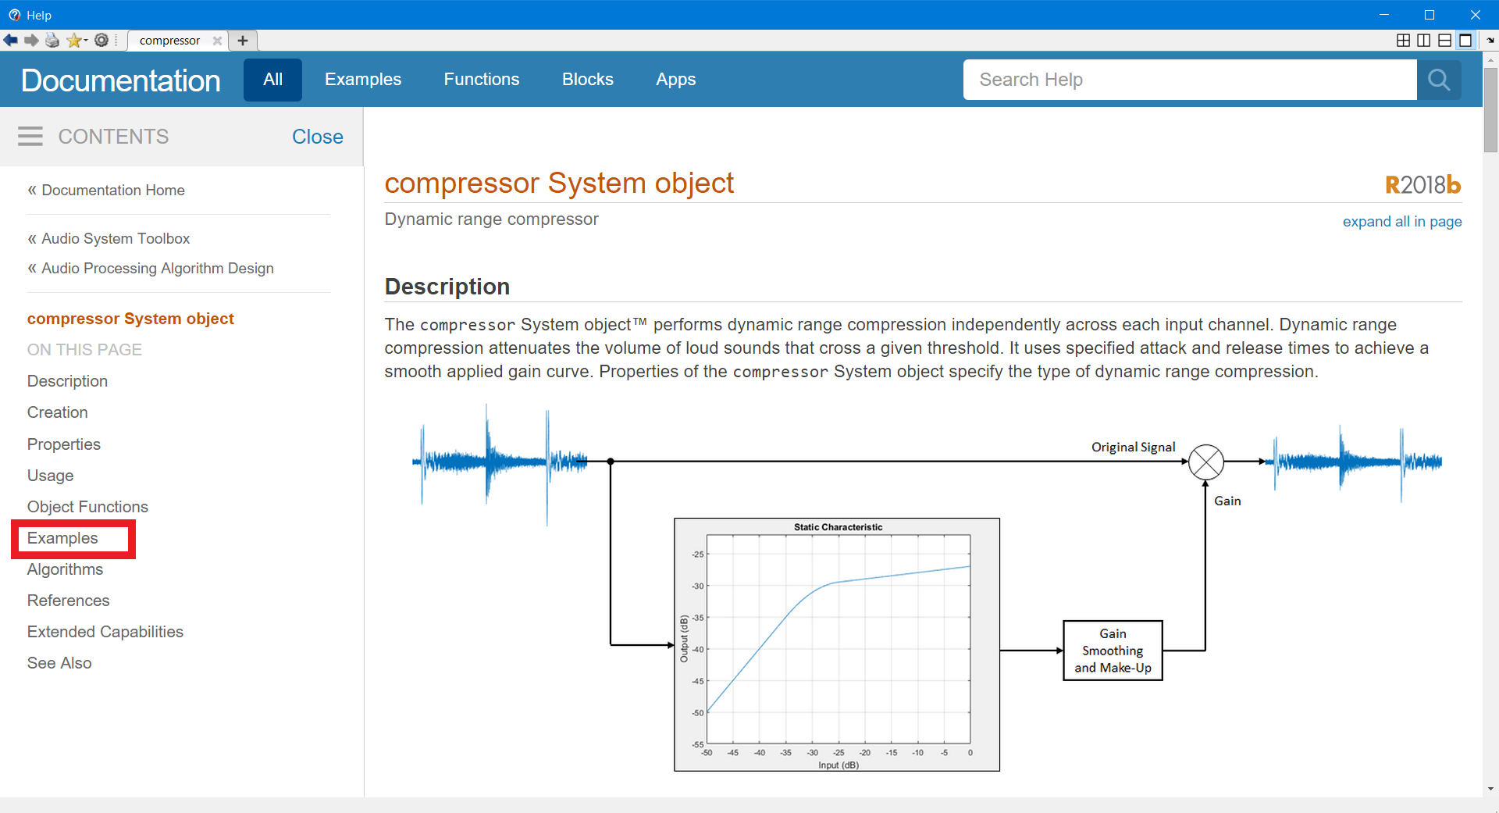

# 2.6 Stage 6: Expand ‘Compress Audio Signal’ and click on ‘Open Live Script’

After opening the example live script file, it was modified according to the needs.

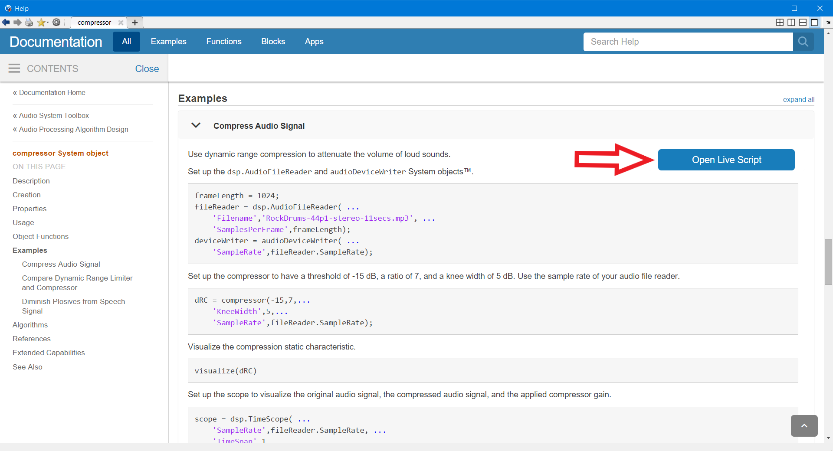

# Simulations Results

## Running the Programs

In order to run this program, just open the **DRCUsingAudioSystemTB_SamiraAbedini2021.mlx** live script file in Matlab Environment and click the Run button from live editor in Matlab toolstrip (as shown by red circle in below).

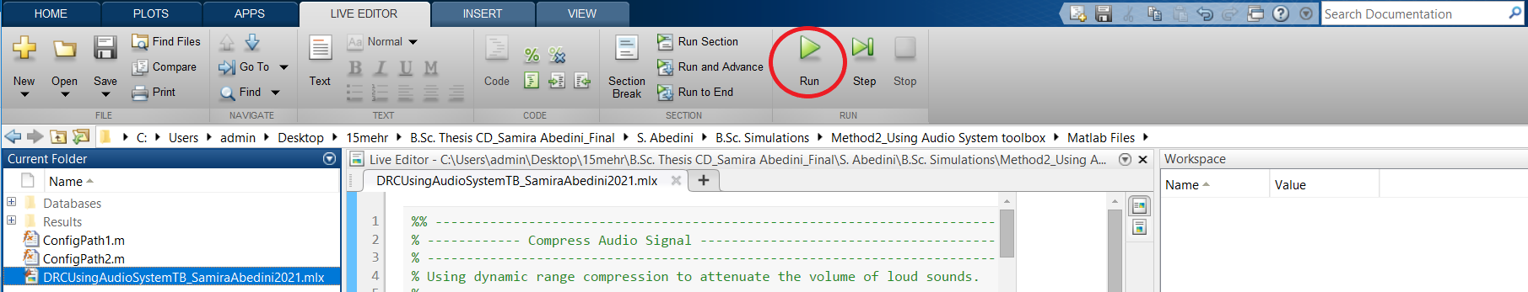

Note:

The input signal , ‘**noisy.wav**’ file , is located in ‘**B.Sc. Simulations\Method2_Using Audio System toolbox\Matlab Files\Databases**’ File.

The output signal , ‘**CompressedSignal2.wav**’ file , will be saved in ‘**B.Sc. Simulations\Method2_Using Audio System toolbox\Matlab Files\Results\Compressed Signal**’ file.

## Experimental Results

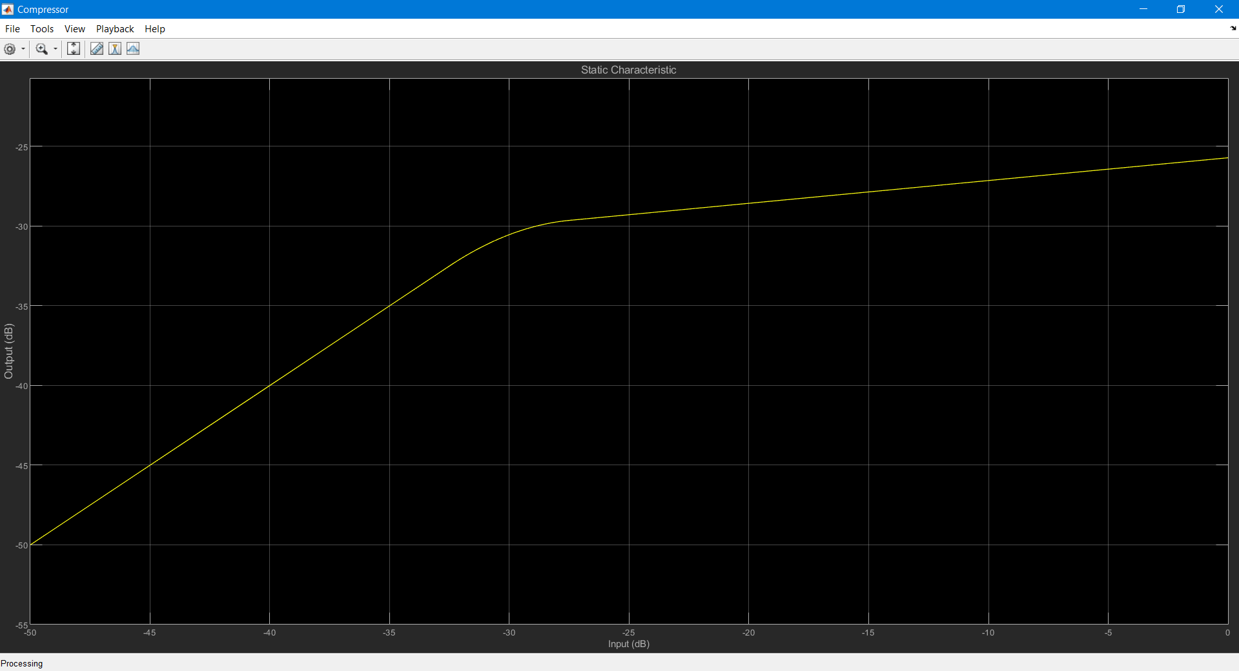

**Figure 4:** output (static characteristic)

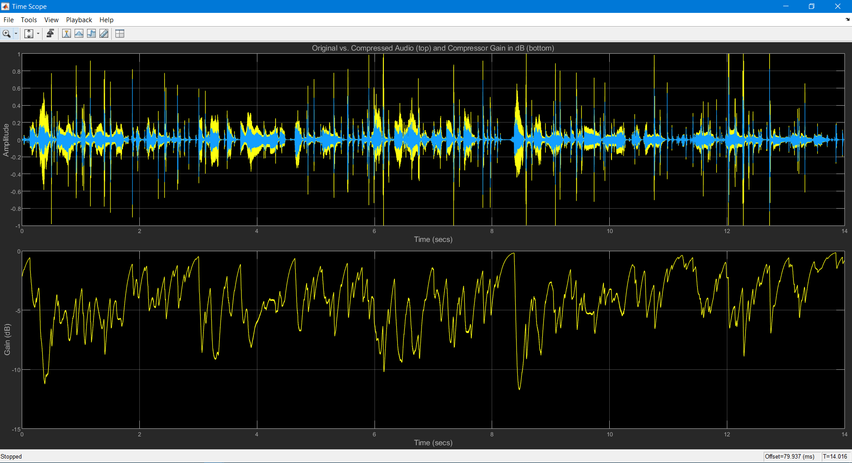

**Figure 5:** compressed signal and gain

# References:

1. P. Dutilleux, et al., “Nonlinear Processing, Chap. 4,” in Dafx:Digital Audio Effects, U. Zoelzer, Ed. (2nd ed:

Wiley, John & Sons, 2011), p. 554.

1. J. O. Smith, Introduction to Digital Filters with Audio Applications (Booksurge Llc, 2007).…
2. Giannoulis, Dimitrios & Massberg, Michael & Reiss, Joshua. (2012). Digital Dynamic Range Compressor Design—A Tutorial and Analysis. AES: Journal of the Audio Engineering Society. 60.
3. <https://www.mathworks.com/help/audio/ref/compressor-system-object.html>